Tech Saksham

Capstone Project Report

ARTIFICIAL INTELLIGENCE AND MACHINE LEARNING FUNDAMENTALS

ML based Spam E-Mail Detection
“College Name”
NM ID | NAME
au513521114012 | PURUSHOTHAMAN R

Trainer Name: RAMAR
Master Trainer:

ABSTRACT

Spam email is one of the biggest issues in the world of internet. Spam emails not only influence the organizations financially but also exasperate the individual email user. This paper aims to propose a machine learning based hybrid bagging approach by implementing the two machine learning algorithms: Naïve Bayes and J48 (decision tree) for the spam email detection. In this process, dataset is divided into different sets and given as input to each algorithm. Total three experiments are performed and the results obtained are compared in terms of precision, recall, accuracy, f-measure, true negative rate, false positive rate and false negative rate. The two experiments are performed using individual Naïve Bayes & J48 algorithms. Third experiment is the proposed SMD system implemented using hybrid bagged approach. The overall accuracy of 87.5% achieved by the hybrid bagged approach based SMD system.

Keywords: Correlation based feature selection, Spam filtering, Hybrid bagged approach, J48 algorithm, Naïve bayes, Text mining.

INDEX

Sr. No. | Table of Contents | Page No.
1 | Chapter 1: Introduction  - Problem Statement  - Proposed Solution  - Feature  - Scope  - Future Work | 1 - 8
2 | Chapter 2: Services and Tools Required  2.1 Service Used  2.2 Tools and Software used | 9 - 15
3 | Chapter 3: Project Architecture  3.1 Architecture | 16 - 18
4 | Chapter 4: Project Outcome | 19 - 23
5 | Conclusion | 24
6 | Future Scope | 25
7 | References | 26
8 | Code | 28

CHAPTER 1
INTRODUCTION
  - Problem Statement

Email system is one of the most effective and commonly used sources of communication. The reason of the popularity of email system lies in its cost effective and faster communication nature. Unfortunately, email system is getting threatened by spam emails. Spam emails are the uninvited emails sent by some unwanted users also known as spammers [1] with the motive of making money. The email users spend most of their valuable time in sorting these spam mails [2]. Multiple copies of same message are sent many times which not only affect an organisation financially [3] but also irritates the receiving user. Spam emails are not only intruding the user’s emails but they are also producing large amount of unwanted data and thus affecting the network’s capacity and usage. In this paper, a Spam Mail Detection (SMD) system is proposed which will classify email data into spam and ham emails. The process of spam filtering focuses on three main levels: the email address, subject and content of the message [4]. All mails have a common structure i.e. subject of the email and the body of the email. A typical spam mail can be classified by filtering its content. The process of spam mail detection is based on the assumption that the content of the spam mail is different than the legitimate or ham mail. For example words related to the advertisement of any product, endorsement of services, dating related content etc. The process of spam email detection can be broadly categorized into two approaches: knowledge engineering and machine learning approach [5]. Knowledge engineering is a network based approach in which IP (internet protocol) address, network address along with some set of defined rules are considered for the email classification. The approach has shown promising results but it is very time consuming. The maintenance and task of updating rules is not convenient for all users. On the other hand, machine learning approach does not involve any set of rules and is efficient than knowledge engineering approach [6]. The classification algorithm classifies the email based on the content and other attributes. For most of the classification problems the process of feature extraction and selection is very important. Features play a vital role in the process of classification. In this paper, a correlation based feature selection (CFS) [7] method is used for feature extraction. The CFS approach extracts the best features from the pool of features for efficient classification results. In order to remove the drawbacks of current model a novel hybrid bagged technique is introduced in the proposed spam mail detection (SMD) system. Fig. 1 presents the basic process of email filtering. The proposed spam mail detection system is inspired from the effectiveness of machine learning approach. In spam mail detection system, initially email data is collected. The email data collected is raw and unstructured in nature. In order to reduce the computations and to obtain accurate results, email data needs to be pre-processed. The data is pre-processed by removing stop words, stemming and word tokenization is also performed to acquire valuable information. Then, CFS based i.e. correlation based feature selection is performed to get the best selected features from the pool of features. The pre-processing step reduces the dimensionality of data and features in the form of bag of words are then extracted. For the classification a bagged hybrid approach (which is combination of Naïve Bayes classifier and J48) is used in order to make the classification stronger and more accurate. The dataset is randomly divided into different sets and serves as input to each classification algorithm. The bagging approach combines the classification results of the two machine learning algorithms to evaluate the final classification result.

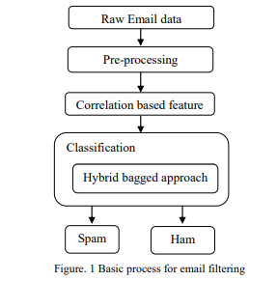

  - Proposed Solution

Email system is one of the most common and popular communication systems. Organisations from all over the world are making their efforts in order to identify the spam mails. The work of authors to identify the ham and spam emails is discussed here. Table 1 illustrates the comparative work of authors by stating the classification techniques, dataset, feature extraction approaches and drawbacks. In order to classify the email as ham or spam, a filtering technique is required for its classification. Mohamad and Selamat [8] have proposed a spam email filtering system using two different features selection methods to classify the emails. They have considered English and Malay email dataset and after the pre-processing of the dataset features are selected using TF-IDF and rough set theory method. Then machine learning technique is applied for the classification purpose showing some reasonably good results. Another machine learning algorithm based work for the classification of email data was presented by Harisinghaney et al. [9]. The algorithmic implementation includes KNN, Naïve Bayes and DBSCAN algorithms and showing effective results when the algorithms are applied on pre-processed data.

  - Feature

Further, Youn and Mcleod [10] proposed an ontology based email filtering method. The considered dataset is classified using J48 decision tree based algorithm. A RDF language based ontology is created by Jena in order to test the results obtain after the classification. Authors have also adapted the optimization techniques. Faris et al. [11] have used feed forward neural network based method to detect the spam emails and to optimize the results as well. The neural network is trained with the help of Krill Herd algorithm. The pre-processed dataset is equally divided into two halves for the training and testing purpose. The optimized classification results obtained from neural network are compared with other optimization algorithms like Genetic algorithm and Back propagation. The experimental results shown by Kill Herd algorithm are more accurate than the other two algorithms. Another optimization based system is proposed by Al-Shboul et al. [12] for the detection of spam mails. The authors have considered a hybrid approach for the email filtration process. In the first phase, Particle Swarm Optimization based algorithm is considered in order to select the best and optimized features. In the second phase, Random forest algorithm is trained with the selected features form the previous phase in order to classify the email dataset into ham and spam emails
- Word frequency: Frequency of specific words or phrases commonly found in spam emails (e.g., "FREE!", "URGENT!", "Click Here").
- Presence of URLs and attachments: Flag emails containing URLs or attachments, as these can be potential indicators of spam.
- Blacklist lookup: Checking sender email addresses and URLs against blacklists of known spam senders and malicious websites.
- Part-of-speech (POS) tagging: Identifying the grammatical role of words (e.g., noun, verb) to understand the context and identify unusual word usage patterns in spam emails.
- Named entity recognition (NER): Extracting named entities like person names, locations, and organizations to detect inconsistencies or suspicious sender information.
- Sentiment analysis: Analyzing the sentiment of the email text to identify overly promotional or emotionally charged language often used in spam emails.

  - Advantages

- Integration with Email Filtering Software: Integrating the trained model with existing email filtering software. This allows for real-time spam detection on incoming emails. The model generates spam probability scores for each email, and emails exceeding a predefined threshold are classified as spam and moved to a designated spam folder.
- Monitoring and Retraining: Continuously monitoring the model's performance and retraining it periodically with new data to adapt to evolving spam tactics and maintain high accuracy.
This proposed solution provides a comprehensive framework for building a spam email detection system. By leveraging feature engineering, machine learning, and NLP techniques, we can achieve highly accurate spam classification, improving user experience and enhancing email security.
  - Scope

There are various techniques for the classification of emails into spam and non-spam emails. Tuteja [13] has presented the review on different techniques for the spam and non-spam email classification. The author has presented different classification algorithms like Support Vector Machine (SVM), Naïve Bayes (NB) classifier, Neural Network (NN), J48 Decision Tree based classifier for the classification of the emails. In this paper, the author Tuteja [14] has proposed a system based on neural network for the classification of the emails into spam and non-spam emails. A review on current trends and techniques for email classification has also been presented by Mujtaba et al. [14]. The author has suggested three levels in every classification technique. The preprocessing state which includes conversion of words into tokens, removal of stop words etc. The second phase is learning. In this level, the feature set is prepared which is required for the classification. Here features are extracted and then selected. The third and final level is classification level. In this level, the classifier is considered which classifies the email into its respective class. Different algorithms are considered for the classification like, support vector machine, logistic regression, regression trees, and random forest etc to name as few.
Recently, machine learning algorithms are integrated with some other algorithms in order to acquire more effective results. Ajaz et al. [15] have proposed a spam email detection system by considering a hybrid approach of Secure Hash algorithm and Naïve Bayes machine learning classifier. The feature set is considered with the help of Naïve Bayes classifier. With the help of SHA (Secure Hash algorithm) a function is generated which considers the email in form of message M. The message M is further classified into two categories S and L. where S stands for the spam message and L indicates genuine message. The work proposed by Ajaz et al. [15] has shown effective results.

  - Future Work

Expanding the Capabilities of Spam Detection:
The proposed spam email detection system offers a robust foundation for filtering unsolicited messages. However, the fight against spam is an ongoing battle, requiring continuous adaptation and exploration of new techniques. Here, we explore some promising avenues for future research:

Improved Spam Detection Techniques:

- Advanced Deep Learning Models:
Investigating the use of more advanced deep learning architectures like Generative Adversarial Networks (GANs) to better identify emerging spam patterns and mimic spammer tactics for more robust detection.

- Graph-based Techniques:
Exploring graph-based approaches to model relationships between email senders, recipients, and URLs. This can help identify spam campaigns and malicious networks.

Real-time Spam Detection and Adaptation:
- Threat Intelligence Integration:
Integrating real-time threat intelligence feeds into the spam detection system. This allows the model to adapt to new spam campaigns and phishing tactics as they emerge.
- Adaptive Learning Models:
Developing online learning algorithms that can continuously update the model with new data, enabling real-time adaptation to evolving spam strategies.
Multilingual Spam Detection:
- Multilingual NLP Techniques:
Developing models that can effectively detect spam emails across various languages, catering to a broader user base and addressing the global nature of spam campaigns.
- Code-mixed Spam Detection:
Exploring techniques to handle code-mixed emails containing text from multiple languages, a growing challenge in the spam landscape.
Human-in-the-Loop Systems:
- User Feedback Integration:
Developing a system that incorporates user feedback on misclassified emails to improve the model's accuracy over time. This can involve allowing users to report false positives or false negatives.
- Explainable AI (XAI): Implementing explainable AI techniques to provide users with insights into the model's decision-making process, fostering trust and enabling users to identify potential biases in the model.

CHAPTER 2
SERVICES AND TOOLS REQUIRED

2.1 Services Used

In this section, the preliminaries of Naïve Bayes classifier and J48 decision tree algorithm are discussed.
Naïve Bayes classifier is based on Bayes theorem with an assumption of strong independence [16]. The classifier is a probability based classifier which computes the class probabilities of the given instances. The probability set is calculated by computing the combinational and frequency values of the data set. The class probability which is nearest to the rear end will be picked by the classifier. The Naïve Bayes classifier is a multiclass classifier and works efficiently with supervised learning approach. The concept of the Naïve Bayes classifier is explained with the help of Eq. (1).

𝑃(𝑦|𝑥) = 𝑃(𝑥|𝑦) 𝑃(𝑦) /𝑃(𝑥) (1)

Here, x is the set of feature vectors (x1, x2, x3,….xn) and y stands for the class variable with 𝑚possible outcomes (y1, y2, y3,….yn). P(y|x) is the posterior
probability which depends on the likelihood of the feature set or attribute value belonging to particular class P(x|y), P(y) is the prior probability and P(x) is the evidence depending on the known feature variables.

Multinomial naïve bayes: The Naïve Bayes classifier used in the proposed work is Multinomial Naïve Bayes classifier. In this classifier, data is represented in the form of counts of word vectors [17]. The parameterised distribution by vectors θy = (θy1,…, θyn) for each y class, where n represents features and θy1 is the probability P(xi|y) of feature i in particular sample belonging to class y. Eq. (2) shows Multinomial Naïve Bayes classifier mathematically.

𝜃̂𝑦𝑖 = 𝑁𝑦𝑖+ 𝛼 /𝑁𝑦+ 𝛼𝑛 (2)

Let us consider an example to show the working of Naïve Bayes classification algorithm. Assume that the email contains the word “profit”. People who operate on email system for their communication would know that this email is likely to be a spam email. The spam mail detection system implemented using Naïve Bayes classification algorithm computes the probability to classify the email with word “profit” using the Eq. (3).

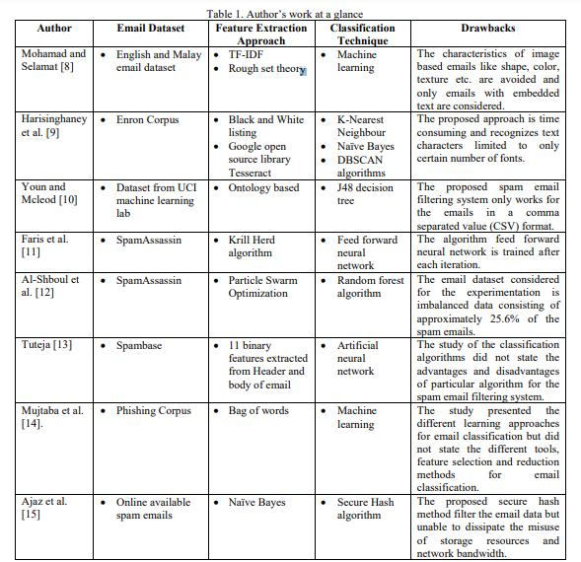

(𝑠|𝑤) = 𝑝(𝑤|𝑠) 𝑝(𝑠) /𝑝(𝑤|𝑠) 𝑝(𝑠)+ 𝑝(𝑤|ℎ)𝑝(ℎ) (3)

Here 𝑤 representing the word “profit”ℎ and 𝑠 represents email classes ham and spam respectively. The probability of email belonging to spam class containing word “profit” is p(s|w) depends on the overall probability of any email belonging to spam class p(s), the probability of occurrence of word “profit” in spam emails p(w|s),the overall probability of any email belonging to ham class p(h) and the probability of occurrence of word “profit” in ham emails p(w|h). Algorithm 1 presents the training and applicability of the Multinomial Naïve Bayes classification algorithm. In this algorithm, C is set of all classes, c is the computed class, N is number of documents and Nc is number of documents in the class c.

2.2 Tools and Software used
This section represents the workflow of the Spam Mail Detection (SMD) System for the classification of emails into ham and spam emails. The SMD system consists of strong classification abilities introduced with the concept hybrid bagged approach. The feature selection method is performed with correlation based feature selection and performed classification with novel hybrid bagging approach. The bagging approach is a hybrid approach where decision tree based J48 algorithm and Naïve Bayes Multinomial classifier is the classification purpose. The flow chart of the SMD system for email classification is presented in fig. 3. The SMD system classifies the email into spam and ham emails. The text based email dataset considered is initially pre-processed for efficient feature extraction. The classification approach considered is a hybrid bagged approach. The SMD system consists of four modules (sub-sections 4.1 to 4.4) of Email Dataset Preparation, pre-processing of data, feature selection and hybrid bagged approach. Also a working model is explained in sub-section 4.5.

Data Acquisition:
- Public Datasets: Resources like Enron Email Dataset, SpamAssassin Public Corpus, or UCI Machine Learning Repository offer pre-labeled datasets for training your spam detection model.
- Custom Email Collection: If a public dataset doesn't meet your specific needs, you can collect your own email corpus. Tools like:

- MailCatch: Web-based service for creating temporary email addresses to collect spam samples.

- SpamSieve: Email client plugin that allows users to easily categorize emails as spam or legitimate, aiding in data collection.

Email dataset An email dataset is prepared for the Spam mail detection system. Different emails are randomly collected from Ling spam dataset [19]. The dataset consists of total number of 1000 emails consisting of
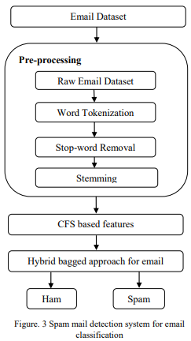

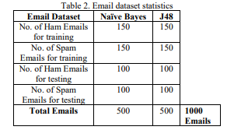

both ham and spam emails for the classification purpose. Since the approach considered is bagging approach, the dataset is divided into sets for each classifier algorithm. Two sets of 500 emails each have been prepared. Out of which 300 emails each are used for training purpose for both the Naïve Bayes and J48 algorithm and 200 each for the testing purpose. The statistics of dataset is shown in table 2.

Pre-processing of dataset:
The email dataset considered is raw in nature. So it needs to be pre-processed before further consideration. The pre-processing phase consists of three steps. Initially the tokenization of the text data is done. The sentence is split into words known as tokens. From the tokenized words, stop words are removed. Stop words are unwanted words having no linguistic meaning. A text file of approximately 670 stop words is manually prepared and words are removed from the text at the time pre-processing. The third step in the pre-processing module is the stemming. The process of stemming reduces the word to its base word. Stop word removal and stemming are important steps in the pre-processing phase as they help to reduce the search space for efficient feature extraction and selection.

Feature selection:
Features play an important role in any of the classification system. SMD system works with assumption that spam mail differs than the ham mail in terms of its content. The feature set contains different features like alphanumeric words, language, grammatical or spelling errors, inappropriate words (words related to advertisement of products/services, dating, adult words etc), frequency count, document length etc. In SMD system correlation feature selection (CFS) method is used. CFS only identifies the best features among the pool of features which are helpful in improving the performance of the system. Correlation based feature selection method works on the assumption that, “Good feature subsets contains features highly correlated with the classification, yet uncorrelated to each other” [7]. Initially text data with feature set is considered as bag of words. The term frequency method is considered to show the number of words per document. The frequency of all words is calculated and words with frequency below a threshold value are eliminated. This method indicates the usefulness of the words and also reduces the search space. The obtained feature set is further reduced using correlation based feature selection method.

Correlation based feature selection method only selects the feature set which are most related to the particular class. If f is the feature set with k number of features and c is number of classes then Eq. (4) presents the mathematical formulation of correlation based feature selection method.

𝐶𝐹𝑆 = 𝑚𝑎𝑥𝑆𝑘 [ 𝑐𝑓1 ,𝑟𝑐𝑓2 ,𝑟𝑐𝑓3 ,…,𝑟𝑐𝑓𝑘/ √𝑘+2(𝑟𝑓1𝑓2 + … 𝑟𝑓𝑖 𝑓𝑗 + … 𝑟𝑓𝑘𝑓1 ) ] (4)

Here rcf is the average of feature-class correlation, rff is the average of feature-feature correlation.

CHAPTER 3
PROJECT ARCHITECTURE
3.1 Architecture
The fourth and last module is the classification module. A hybrid bagged approach with a combination of the decision tree based J48 algorithm and Naïve Bayes Multinomial classifier is considered for classification. Bagging approach also called as bootstrap aggregating approach decreases the variance by considering the combinations of the multiple repeated sets of the same dataset. In this approach, multiple models are generated by dividing the email dataset is randomly divided into separate sample email datasets: SED1 and SED2. Each sample email dataset is considered to train individual classifier. The overall system’s result is the average of the result of the two classification algorithms. J48 algorithm and Naïve Bayes are used
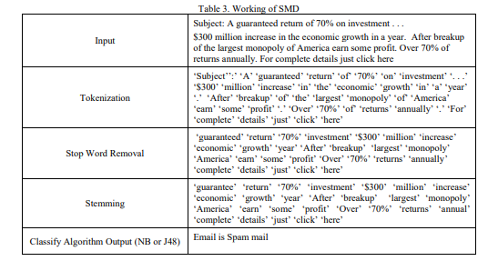

for the multi class learning and for the classification. The classification result considered is the average of the predicted values. Fig. 4 presents the concept of bagging.
Working of SMD The detailed description of the modules of Spam Mail Detection (SMD) system is given with the help of the following example. An example of a random email is considered to explain the step-wise working of Spam Mail Detection system. The SMD system takes input in the form of an email and delivers the output in the form of either spam or ham as shown in table 3.

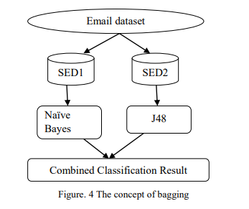

The overall result of spam mail detection system is the aggregation of the predictions of both the algorithms and thus ensuring a system with accurate and reliable results. The efficiency of proposed spam mail detection system is encountered by evaluating the performance parameters. Parameters like precision, recall, accuracy, F-measure, true negative rate, false negative rate and false positive rate are calculated in order to evaluate the performance of the Spam mail Detection system. The performance evaluation of the SMD system is based on different measures presented in table 4. The system has achieved an overall accuracy of 87.5% which is the average of the accuracies achieved by the two classifying algorithms. The accuracy achieved by Naïve Bayes classifier is 83.5% with precision and recall value of 85.26% and 81% respectively. Whereas, the accuracy achieved by J48 algorithm is 91.5% which with the precision and recall value of 93.68% and 89% respectively. Table 5 presents the evaluated results of the three experiments: Naïve Bayes, J48 algorithm and hybrid bagged approach respectively.

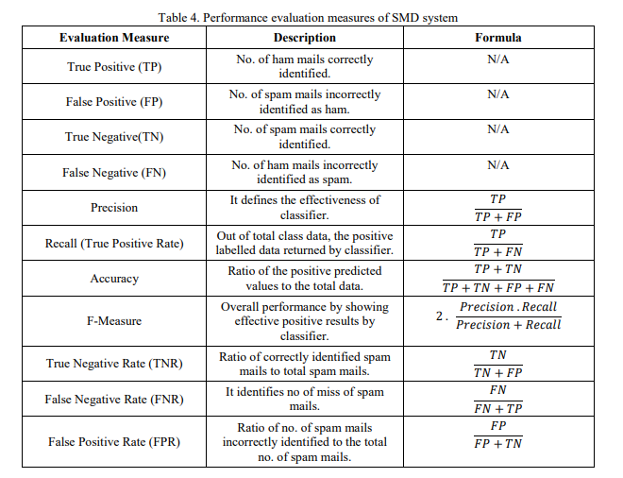

CHAPTER 4
PROJECT OUTCOME
The proposed system is a step forward towards building a spam filter with essential considerations to support performance in an on–line working environment. It aims to detect spam emails. For that, the Naïve Bayesian (supervisedlearning) approach has been adopted to develop the proposed spam classifier. a- Reading (.eml) files: This is a first step to be taken in the filtering system execution whenever a file with .eml extension is encountered. In this process, email parsing is done by breaking up its content into header and body. The body of the email is the only part that is considered in the proposed mechanism in order to be passed to the following process. b- Preprocessing: Its main objective is to drop out any redundant data, hence keeping those only parts of an email body that give useful information which helps guiding efficient classification. Preprocessing consists of the following stages:
• Tokenization: Typically, the term “tokenization” referred to the process of breaking out a stream of text into its constituent meaning full units (called tokens). From a linguistic perspective, tokenization is accomplished on a word level, hence breaking the stream of text out into words. A predefined set of separators is used for this purpose. In the proposed tokenizer the punctuations mark, numbers, white space, and html tags were considered in breaking out the body of the email message into a sequence of features.
• Stop Words Removal: Stop words such as “the”, “are”, “with”, “and”, “to” etc. are some of the common words which occur almost in all textual information. These need to be removed because these stop words does not carry any useful information for helping to decide whether a mail message belongs to a classify or not. The elimination of the stop words from the mail message, will lead to a reduction in the dimensionality of the features space. The list of 429 stops words used in this thesis. This stop word list is obtained from [15].
• Stemming: is the term used in linguistic morphology and information retrieval to describe the process of reducing derived words to their word stem (base or root form). Many algorithms have been developed for stemming. Amongst are: look up algorithm, matching algorithm, and the popular Porter’s stemming algorithm. For the proposed work, a look-up-like method was developed. In this method a table including the stem of candidate words together with corresponding derivatives is built. Part of this table is shown in Table 1. Note that data resource for this method was the Webster dictionary of English usage.
c- Features Extraction: Is a method of construct the combinations of the variables to get around a problem which still describe the data with appropriate accuracy. A feature can be a word, an html tag, a phrase, etc. Since the “body” is the part of an email message this work is concerned with, and this body is a stream of textual data, and since the words of that body are considered to underline feature, of an email, a Bag of Word method was used throughout this work to carry on feature extraction. In this method, an email is represented as a bag of its body’s words (features). A list of 149 features was considered, including those commonly used by most spam email. Some of these features were thought fully adopted from [16]. Additional others were suggested such as: “http”, “www”, and all strings of capital letters. d- Features Selection: Two algorithms of feature selection were used in this work: Information Gain (IG) and Word Frequency (WF), both of which aimed at reducing dimensionality of the features. IG for individual feature F is calculated as in the equation (4).
C j stands for the jth class out of total of K classes that are restricted to 2 (in the problem in hand): spam, non-spam, P (C j) stands for the probability of class C j, P (F) stands for the probability of a feature F being appeared in email messages, p(C j / F) stands for the probability of a feature F being appeared at least once in message of class C j, (F¯): stands for the probability that feature F not being appeared in the training dataset, p (C j / F¯): stand for the probability of feature F not being appeared in any of the messages of class C j [17].
e- Training: This is the process to train the proposed spam detection for doing the required classification on input emails. In this work 3800 emails from CSDMC2010 spam corpus were used for Training. This process was accomplished by stepping through the following Sequence of tasks: 1-present the NB classifier with each of the following sets of features: Set-A: The original set of 149 features. Set-B: Set of those only features selected according to IG Method. Set-C: Set of those only features selected according to WF Method. 2- As a result, three classification models would consequently be obtained whose training results were to be used in testing phase: All-feature NB model (NB-All F): the classifier model trained by set-A. IG-based NB model (NB-IG F): the classifier model trained by set-B. WF-based NB model (NB-WF F): the classifier model trained by set-C.
F- Testing: This is the process to classify the unlabeled messages (in the dataset) into Spam and non-spam Mails. This process uses the result from training phase with entries of new unlabeled messages to classify it. At this step, a set of testing emails consists of 500 labeled emails was used. Conditional probabilities concerning email and posteriori probability were calculated at the testing process. Now, it’s time to continue calculating the conditional probability, but this time for the testing emails at each class, using the equation (3) and assuming the conditional independence of features. To avoid obtaining a result of zero out of this equation, Laplacian estimator was introduced each time the frequency xi of the ith feature in the testing email in hand was equal to zero. Thus, increment frequency of xi by one, as well as increment frequency of both classes (back in the training dataset) by a value equals number of available values of the ith feature.
3- Calculate the priori probability and the conditional probability: Compute the priori probability of each class p (Cs), p (Cns). Where: P (Cs): is the probability of spam mails in the training dataset. P (Cns) is the probability of non-spam mails in the training dataset. Compute the conditional probability P (xi|Cj) for the email’s value xi of its ith feature that exists in either of the foresaid sets A-C. This probability estimates the relative frequency of mails in Training dataset having value xi as the ith feature in class Cj.
At last, the posteriori probability is left to be calculated for each unlabeled email X accord to equation (2). Two probabilities are produced: P (Cs |X); probability of X being a spam email, P (Cns |X); probability of X being a non spam email. Finally, classification is attempted by deciding the class with the maximum posteriori probability to label email X with accordingly. g- Extension of Naive Bayesian Classifier (ENB): Now that the NB classifier done, testing phase showed that certain percentage of misclassification was still exist. Is due to the slight difference between spam and non spam probabilities recorded for some emails. To deal with this issue, an ad-hoc tolerance algorithm was proposed to tolerate left over of misclassification by NB algorithm. It depends mainly on some statistical measured to enhance the overall system behavior. Algorithm 1 presents the proposed steps. It is worth to outline here that the key (strength) impact of this extension lies on this algorithm handle the effect of feature individually on misclassified email. Wherse NB, by itself, were conceding the overall effect of features on tested email, hence weaken the effect of probability some of the vital features that otherwise support robust classification.

This section presents the results of evaluation of performance of this work for solving the spam problem. The criteria that were used to measure the performance of this work are: accuracy (AC), recall(R), precision (P), false positive (FP), false negative (FN), and the error rate (ERR). These criteria were calculated by using the equations 6, 7, 8, 9, 10, and 11 respectively.
AC = ((S→S) + (L→L)) / ((S→S) + (L→L) + (S→L) + (L→S)) (6).
R = (S→S) / ((S→S) + (S→L)) (7).
P = (S→S) / ((S→S) + (L→S)) (8).
FP = (L→S) / ((L→S) + (L→L)) (9).
FN= (S→L) / ((S→L) + (S→S)) (10).
ERR= AC – 1 (11).
Where: S: spam, L: legitimate, S→S: The total number of spam emails that are classified as spam emails, L→L: The total number of legitimate emails that are classified as legitimate emails, S→L: The total number of spam emails that are classified as legitimate emails, L→S: The total number of legitimate emails that are classified as spam emails. Four experiments were conducted. (Exp1) conducted on the NB with all features (149 features), (Exp2) conducted on NB using IG with 75% of features, (Exp3) conducted on NB using WF with 75% of features, and (Exp4) conducted on extension of naïve Bayesian (ENB) with 75% of features. Table 2 depicts the results of these experiments. The results of ENB are better than the results of NB-All F, NB-IG F, and NB-WF F in all evaluation measures (i.e., AC, R, P ,FP, FN, ERR)
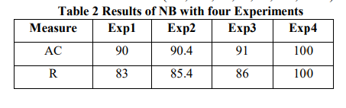

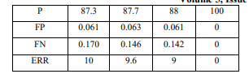

CONCLUSION
This paper has proposed approach to detect unsolicited emails. To detect those messages, certain classifier is needed to identify incoming messages as being spam or legitimate. Deciding a suitable classification method to gives a rewarding performance (in on off-line working environment) is what the proposed work aimed at. The Naïve Bayesian classifier was used in this approach. To classify emails into spam or legitimate, NB classifier needs to be trained, and then tested. The size of 3800 emails for training give the best results. The size of feature set has an evident effect on the performance of the spam classifier. The result gained with proportion 75% of features space was better than those gained with 50% and 25% proportions, in terms of all evaluation measures. Feature selection techniques considerably affect the dimensions of the data and consequently the computation time to construct the classifier. Despite the error rate that dropped down NB classifier at certain settings of its parameters, an ad-hoc statistical step (procedure) has been adequately able to fix those misclassifications. The accuracy of the proposed spam classifier has been affected by the dependency of features on the frequency of one to another’s, when accuracy increased when all features are statistically independent of each other.
Spam email is one of the most demanding and troublesome internet issues in today’s world of communication and technology. Spammers by generating spam mails are misusing this communication facility and thus affecting organisations and many email users. In this paper, a Spam Mail Detection system is introduced which makes use of a hybrid bagged approach for its implementation. The classification algorithms used in this approach are Naïve Bayes and J48. The accuracy achieved by Naïve Bayes and J48 algorithm is 83.5% and 91.5% respectively. The overall accuracy of 87.5% achieved by the hybrid bagged approach based SMD system shows that the experimental results are better when performed on only J48 algorithm. In order to enhance the system’s performance and results, the concept of boosting approach could be considered for future work. The boosting technique will replace the weak classifier’s learning features with the strong classifier’s features and thus enhancing the overall system’s performance.
FUTURE SCOPE

- Improved Spam Detection Techniques:
Exploring advanced deep learning models like Recurrent Neural Networks (RNNs) for more sophisticated spam identification.

- Real-time Spam Detection:
Integrating real-time threat intelligence to identify emerging spam campaigns and adapt the model accordingly.

- Multilingual Spam Detection:
Developing models that can detect spam across various languages, catering to a broader user bas

REFERENCES

[1] Thomas Choi, “Transactional Behaviour Based Spam Detection”, master thesis, Department of Systems and Computer Engineering, Carleton University Ottawa, Ontario, Canada, April 2007.
[2] Jon Kågström, “Improving Naive Bayesian Spam Filtering”, M.Sc. Thesis, Mid /Sweden University Department for Information Technology and Media, spring 2005.
[3] Tariq R. Jan, “Effectiveness and Limitations of Statistical Spam Filters”, University of Kashmir, Srinagar, India, International Conference on New Trends in Statistics and Optimization, 2009.
[4] W.A. Awad, and S.M. ELseuofi, “Machine Learning Methods for Spam Email Classification”, International Journal of Computer Science & Information Technology (IJCSIT), Vol 3, No 1, Feb 2011.
[5] Jincheng Zhang, and Yan Liu, “Spam Email Detection: A Comparative Study”, Techniques for Data Mining Journal, December 6, 2013.
[6] S. Divya, and T. Kumaresan, “Email Spam Classification Using Machine Learning Algorithm”, International Journal of innovative research in Computer and Communication Engineering, Vol.2, Special Issue 1, March 2014.
[7] Nouman Azam, “Comparative Study of Features Space Reduction Techniques.
[8] for Spam Detection”, M.Sc. thesis, National University of Sciences and Technology, 2007.
[9] David Ndumiyana, Munyaradzi Magomelo, and Lucy Sakala, “Spam Detection using a Neural Network Classifier”, Online Journal of Physical and Environmental Science Research, Volume 2, Issue 2, pp. 28-37, April, 2013.

[10] Hasan. S. Alkahtani, Paul .G. Stephen, and Robert Goodwin, “A Taxonomy of Email Spam Filters”, The 12th International Arab Conference on Information Technology, Naif Arab University for Security Sciences,11-12-2011.
[11] Hao Wu, "Detecting Spam Relays by SMTP Traffic Characteristics Using an [12] Autonomous Detection System", Ph.D. Thesis, Loughborough University 2011.
[13] Valerio Freschi, Andrea Seraghiti, and Alessandro Bogliolo, "Filtering Obfuscated Email Spam by means of Phonetic String Matching", springer, Volume 3936, pp. 505-509, 2006.
[14] Hao Wu, "Detecting Spam Relays by SMTP Traffic Characteristics Using an Autonomous Detection System", Ph.D. Thesis, Loughborough University 2011.
[15] Sang-Bum Kim, Kyoung-Soo Han, Hae-Chang Rim, and Sung Hyon Myaeng, “Some Effective Techniques for Naive Bayes Text Classification”, IEEE Transactions on Knowledge and Data Engineering, vol.18, no.11, pp.1457-1466, Nov. 2006.
[16] Sushmita Mitra, and Tinku Acharya, “Data Mining - Multimedia, Soft Computing, And Bioinformatics”, Publisher: Wiley-Interscience; 1 edition September 25, 2003, ISBN: 978-0-471-46054-1.
[17] http://www.lextek.com/manuals/onix/stopwords1.html
[18] Serkan Günal, Semih Ergin, M. Bilginer Gülmezoğlu, and Ö. Nezih Gerek “On Feature
[19] Extraction for Spam E-Mail Detection”, Springer, Volume 4105, pp. 635-642, 2006.
[20] Guo Qiang, “Research and Improvement for Feature Selection on Naive Bayes Text Classifier”, IEEE Conference Publications, 2nd International Conference on Future Computer and Communication, vol.2, 2010, pp.156-159 [21] Wang Chunping, “The study on the spam filtering technology based on Bayesian algorithm” International Journal of Computer Science Issues, Vol. 10, Issue 1, No 3, January 2013.

CODE

